EMERGING METHODS FOR EARLY DETECTION OF
FOREST FIRES

IBM-Project-30216-1660141867

NALAIYA THIRAN PROJECT BASED LEARNING ON PROFESSIONAL READLINESS FOR INNOVATION, EMPLOYNMENT AND ENTERPRENEURSHIP

A PROJECT REPORT ON
Submitted by

A.S.KARISHMA[812419106302]
S.RAMYA DEVI[812419106303]
J.SWETHA[812419106304]
K.LAVANYA[812419106026]

TEAM ID :PNT2022TMID45424
INDUSTRY MENTOR :Shanthi
FACULTY MENTOR :KIRTHIKA B T

BACHELOR OF ELECRONICS AND COMMUNICATION ENGINEERING
M.I.E.T ENGINEERING COLLEGE
TRICHY-7

1)INTRODUCTION
PROJECT OVERVIEW:
Forests are the savior of earth’s ecological balance. Forest fires usually occur in areas remote from populated places, in order to that their detection at an early stage and timely reports to the competent services are of utmost importance. Forest fires are one among the foremost important and prevalent sort of disasters and that they can create great environmental problems for Nature. it's known that they're detectable and simply preventable. One and possibly the foremost important method for shielding forests from wildfires is their early detection. The earliest possible detection enables a rapid response to attenuate the spread. Moreover, information regarding the seat of the hearth is invaluable for the rapid deployment of fire-fighters. Therefore, early detection, containment at the primary stages and extinguishment of a fireplace before it spreads are crucial for wildfire management. To reduce the risk and prevent the forest fire they are big offerings to fight it like planes, fire brigade trucks, also extinguishers to small areas which depends upon the severity of the fire and leads to large investment by concerned agencies. The best way out is early detection of forest fire and prevention. Forest fires are highly destructive and are uncontrollable when it starts spreading over the area. Fire causes respiratory problems for living beings even they are living several kilometers away. The 2019, Australia wildfires almost 15 million acres have been burned and the fire also killed about one billion animals. The 2019, Amazon forest fire was burning at a rate which was not seen in almost a decade. It destroyed the ecosystem and caused destructive climate pollution to the atmosphere. IoT has several sensors to detect multiple factors, so we have used some sensors for forest fire detection. Using the latest technology, it makes the 2 system more reliable and efficient. In this project, we developed an IoT and Web infrastructure for monitoring the forest situation, if there is any issue the system will inform the admin immediately and action can be taken instantly. Several types of sensors used in this developed system are Smoke sensor, temperature sensor, PIR sensor. Also, if any damage occurs, we can also calculate it using ML algorithm, we have trained a model for the same using the python algorithm available on the platform.
PURPOSE:
Forests are the savior of earth’s ecological balance. Forest fires usually occur in areas remote from populated places, in order to that their detection at an early stage and timely reports to the competent services are of utmost importance. Forest fires are one among the foremost important and prevalent sort of disasters and that they can create great environmental problems for Nature. it's known that they're detectable and simply preventable. One and possibly the foremost important method for shielding forests from wildfires is their early detection. The earliest possible detection enables a rapid response to attenuate the spread. Moreover, information regarding the seat of the hearth is invaluable for the rapid deployment of fire-fighters. Therefore, early detection, containment at the primary stages and extinguishment of a fireplace before it spreads are crucial for wildfire management. To reduce the risk and prevent the forest fire they are big offerings to fight it like planes, fire brigade trucks, also extinguishers to small areas which depends upon the severity of the fire and leads to large investment by concerned agencies. The best way out is early detection of forest fire and prevention. Forest fires are highly destructive and are uncontrollable when it starts spreading over the area. Fire causes respiratory problems for living beings even they are living several kilometers away. The 2019, Australia wildfires almost 15 million acres have been burned and the fire also killed about one billion animals. The 2019, Amazon forest fire was burning at a rate which was not seen in almost a decade. It destroyed the ecosystem and caused destructive climate pollution to the atmosphere. IoT has several sensors to detect multiple factors, so we have used some sensors for forest fire detection. Using the latest technology, it makes the 2 system more reliable and efficient. In this project, we developed an IoT and Web infrastructure for monitoring the forest situation, if there is any issue the system will inform the admin immediately and action can be taken instantly. Several types of sensors used in this developed system are Smoke sensor, temperature sensor, PIR sensor. Also, if any damage occurs, we can also calculate it using ML algorithm, we have trained a model for the same using the embedded algorithm available on the platform.

2)LITERATURE SURVEY

EXISTING PROBLEMS:
From sprawling urbans to dense jungles, fire accidents pose a major threat to the world. These could be prevented by deploying fire detection systems, but the prohibitive cost, false alarms, need for dedicated infrastructure, and the overall lack of robustness of the present hardware and software-based detection systems have served as roadblocks in this direction. In this work, we endeavor to make a stride towards detection of fire in videos using Deep learning. Deep learning is an emerging concept based on artificial neural networks and has achieved exceptional resultsin various fields including computer vision. We plan to overcome the shortcomings of the present systems and provide an accurate and precise system to detect fires as early as possible and capable of working in various environments thereby saving innumerable lives and resources.

REFERENCES:
- B. Ko and S. Kwak, “Survey of computer visionbased natural disaster warning systems,” Optical Engineering, vol. 51, no. 7, Article ID 070901, 2012.
- J. R. Martinez-de Dios, B. C. Arrue, A. Ollero, L. Merino, and F. Gómez-Rodríguez, “Computer vision techniques for forest fire perception,” Image and Vision Computing, vol. 26, no. 4, pp. 550–562, 2008
- Y. Meng, Y. Deng, and P. Shi, “Mapping Forest Wildfire Risk of the World,” in World Atlas of Natural Disaster Risk, P. Shi and R. Kasperson, Eds., pp. 261–275, Springer Berlin Heidelberg, Berlin, Germany, 2015.
- P. M. Hanamaraddi, “A Literature Study on Image Processing for Forest Fire Detection,” IJITR, vol. 4, pp. 2695–2700, 2016.
- P. Podržaj and H. Hashimoto, “Intelligent space as a framework for fire detection and evacuation,” Fire Technology, vol. 44, no. 1, pp. 65–76, 2008.
- C. Thou-Ho, W. Ping-Hsueh, and C. Yung-Chuen, “An early fire-detection method based on image processing,” in Proceedings of the 2004 International Conference on Image Processing, ICIP '04, vol. 3, pp. 1707–1710, 2004.
- Y. Wang and J. Ye, “Research on the algorithm of prevention forest fire disaster in the Poyang Lake Ecological Economic Zone,” Advanced Materials Research, pp. 5257–5260, 2012.
- A. D. Alzughaibi, H. A. Hakami, and Z. Chaczko, “Review of human motion detection based on background subtraction techniques,” International Journal of Computer Applications, vol. 122, 2015.
- C. E. Premal and S. S. Vinsley, “Image processing based forest fire detection using YCbCr colour model,” in Proceedings of the 2014 International Conference on Circuits, Power and Computing Technologies, ICCPCT 2014, pp. 1229–1237, 2014.
- V. Vipin, “Image processing based forest fire detection,” International Journal of Emerging Technology and Advanced Engineering, vol. 2, pp. 87–95, 2012.
- L.-H. Chen and W.-C. Huang, “Fire detection using spatial-temporal analysis,” in Proceedings of the World Congress on Engineering, pp. 3–5, 2013.
- T.Fawcett, “ROC graphs: Notes and practical considerations for researchers,” Machine Learning, vol. 31, pp. 1–38, 2004.

PROBLEM STATEMENT DEFINITION:

How might we prevent the forest fire by early detecting methods?
For early detecting of forest fire by using,
- Detects by smoke/flame/spark.
- Detects by temperature,climate changes and humidity.
- Detects spark due to lightning.
- Detects any electronic stortage that can cause fire.
- Detects intentional acts of arson.
- Detects the forest fire using CO2.
- Powerful CCTV and HD cameras are used.
- Regularly removes dry leaves
- IR fame detectors are used
- Install and maintain the smoke alarms
- By satellite monitoring,Monitors 24/7
By detect the forest fire we can reducing and solving the problems,
- Reduces the air pollution.
- Reduces the landslides,soil erosion by protecting strong rooted trees.
- Reduces the risk of eradication of endngered species.
- No need of manual monitoring.
- Reduces the emission of CO2 into the air during fire.
- No loss of life and resources.
- Regular maintainance.
- Highly safe since no involment of human life.
- No need of manual monitoring.

3)IDEATION & PROPOSED SOLUTION

EMPATHY MAP CANVAS:
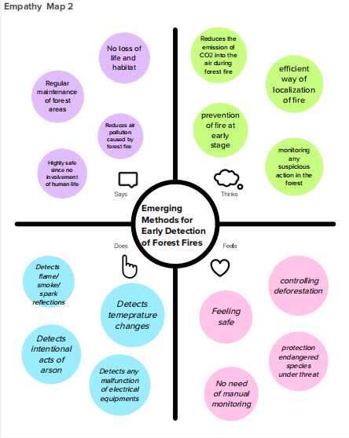

IDEATION & BRAINSTORMING:

Step-1: Team Gathering, Collaboration and Select the Problem Statement

Step-2: Brainstorm, Idea Listing and Grouping
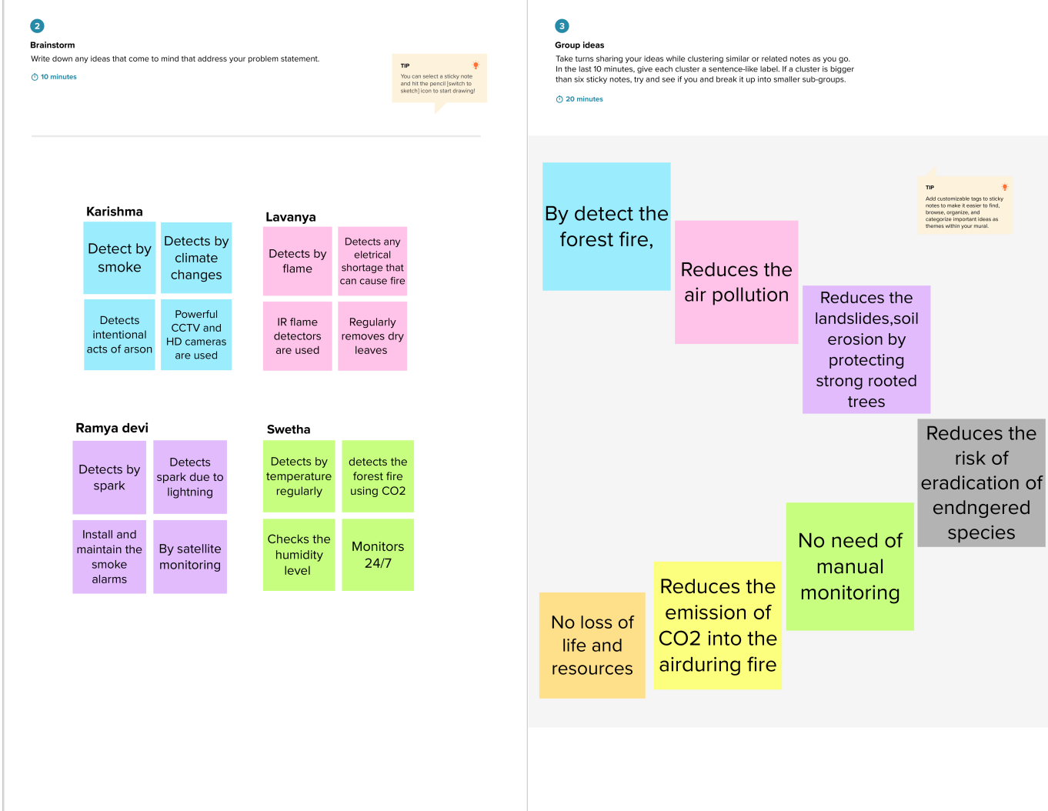

Step-3: Idea Prioritization
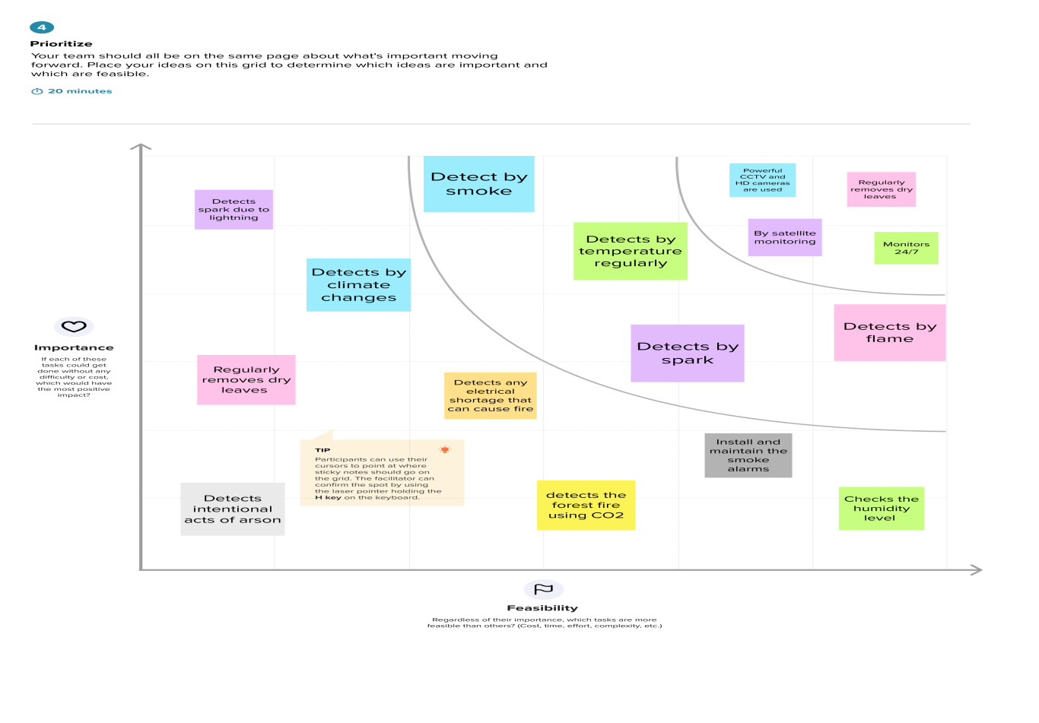
PROPOSED SOLUTION:
S.No. | Parameter | Description
 | Problem Statement (Problem to be solved) | Fires have been a source of trouble.Fires have notable influence over the ecological and economic utilities of the forest, being a prime constituent in a great number of forest ecosystems.Fires are considered as a significant environmental issue because they cause prominent economical and ecological damage despite endangering the human lives. Due to the forest fires, several hundred million hectares of forest and other vegetation are destroyed every year.Therefore,we monitoring and early detecting of forest fire.
 | Idea / Solution description | The propose a platform that uses Unmanned Aerial Vehicles (UAVs),which constantly patrol over potentially threatened by fire areas. The UAVs also utilizethe benefits from Artificial Intelligence(AI) and are equipped with on-board processing capabilities.This allows them to use computer vision methods for recognition and detection of smoke or fire, based on the still images or the video input from the drone cameras.The system is designed for monitor the causing factors of forest fires such as temperature, humidity , air pressure level,oxygen and Carbon dioxide on the surface of air.
 | Novelty / Uniqueness | Using real-time monitoring, instant  data allows pre-cursors to potential  issues (such as corrosion) to be flagged  up and immediately be addressed before  major issues occur. The ability to make  real-time decisions during critical moments  can be vital in preventing forest fires.
 | Social Impact / Customer Satisfaction | - It gives the early detection of smoke and other temperature issues.  - Reduce the potential damage as well as the cost of fire fighting.  - The wireless sensor networks and machine learning was found to be an effective method for fire detection in forests that provides more accurate results.
 | Business Model (Revenue Model) | The section presents the system deployment  strategy and focuses on the sensor probes,  wireless sensor networks and machine learning analysing the data obtained from thedeployment environment.
 | Scalability of the Solution | • Well monitoring system with accurate  indication.  • Easy maintenance.  • Reasonable cost.

PROBLEM SOLUTION FIT:




4)REQUIREMENT ANALYSIS
FUNCTIONAL REQUIREMENTS:
FR No. | Functional Requirement (Epic) | Sub Requirement (Story / Sub-Task)
FR-1 | Monitoring the smoke ,wind speed,CO2 and temperature using sensors | - Fire can be detected by using the amount of smoke. The smoke sensors are used to measure the amount of smoke from the fire, and it could be compared with a threshold value and if it is beyond that value.  - The wind speed is calculated by the wind sensor nodes, which are manually placed in the forest.  - When forest fires burn, they emit large volumes of carbon dioxide gas (CO2); you can use a network , CO2 and temperature sensors for forest fire detection.
FR-2 | Unmanned aerial vehicle(UAV) | The forest fires can be detected by vision-based fire detection systems which can be mounted to an unmanned aerial vehicle (UAVs) for strategically scanning acreage of fire prone areas.
FR-3 | Image processing by CCTV cameras | The cameras rotate continuously, scan the countryside with color, monochrome and near-infrared detectors. A feature-based AI algorithm uses an artificial neural network to scan the images for the telltale heat and smoke signature of wildfires. Under the right conditions, it can see as far as 40 miles away
FR-4 | Data processing using Real time algorithm | The algorithm processes the data in real time on dedicated servers on site.It uses a cloud-based deep learning AI to detect and verify wildfire events in real time, drawing from satellite imagery and historical data.
FR-5 | Light detection and ranging (LIDAR) | The system is used for the forest fire detection with the help of neural network .LIDAR is mainly used in the environmental and atmospheric studies. A lidar contains a photo detector, radiation emitter, signal receiver and signalprocessing hardware and software.
FR-6 | Localization of fire | It use GPS to track their location as they can sends these location details along with the data such as measurements of temperature to cloud (or) other cloud based server.

NON-FUNCTIONAL REQUIREMENT:
FR No. | Non-Functional Requirement | Description
NFR-1 | Usability | AI devices with machine learning verifies that usability is a special and important perspective to analyze user requirements, which can further improve the design quality.
NFR-2 | Security | - Powerful CCTV and HD cameras are used.  - Monitors 24/7  - IR flame detectors are used  - Avoid intentional acts of arson
NFR-3 | Reliability | A real-time and reliable fire detection method for an early warning system is required so that an immediate response to an incident can be made effective.
NFR-4 | Performance | The system is designed for monitor the causing factors of forest fires such as temperature, humidity , air pressure level,oxygen and Carbon dioxide on the surface of air by using sensors.  The CCTV cameras is use for image processing and detect the forest fire.  The GPS is use to track the location of forest fire.
NFR-5 | Availability | By developing to more advanced system byintegrating wireless sensors with CCTV for added protection and precision. The algorithm shows great promise in adapting to various environment.
NFR-6 | Scalability | By detect the forest fire we can reducing air pollution, landslides,soil erosion by protecting strong rooted trees,the emission of CO2 into the air during fire,No loss of life and resources.

5)PROJECT DESIGN

DATA FLOW DIAGRAMS:
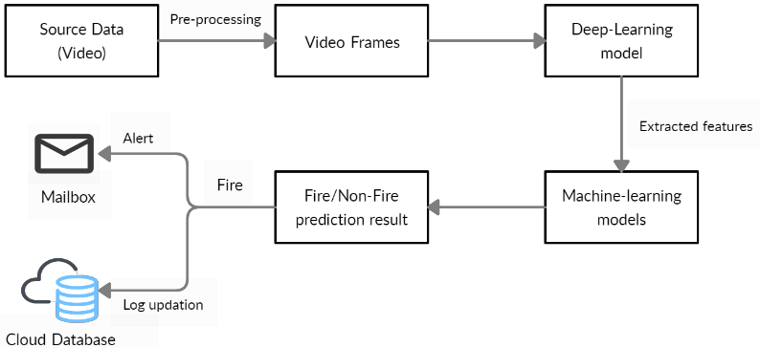

DFD:
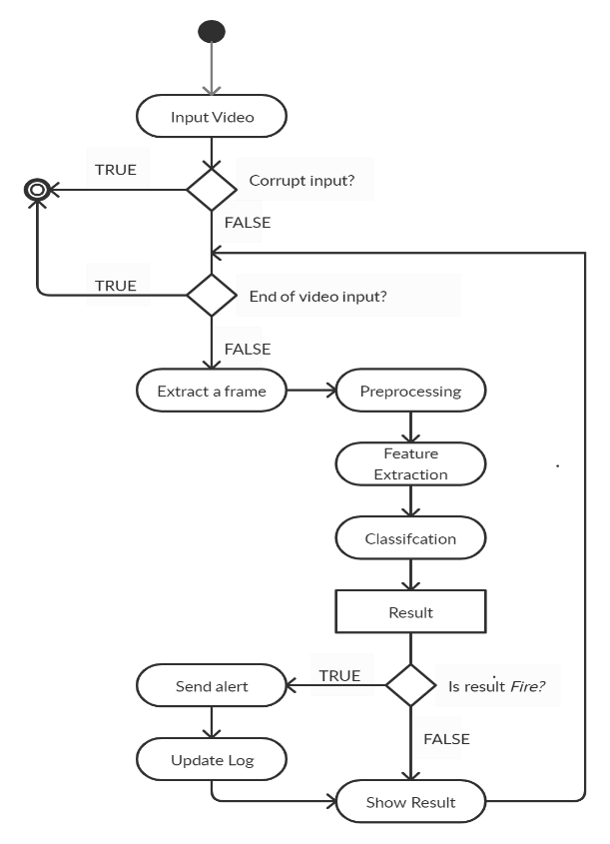

6)SOLUTION AND TECHNICAL ARCHITECTURE:

Technical Architecture:

Solution Architecture:
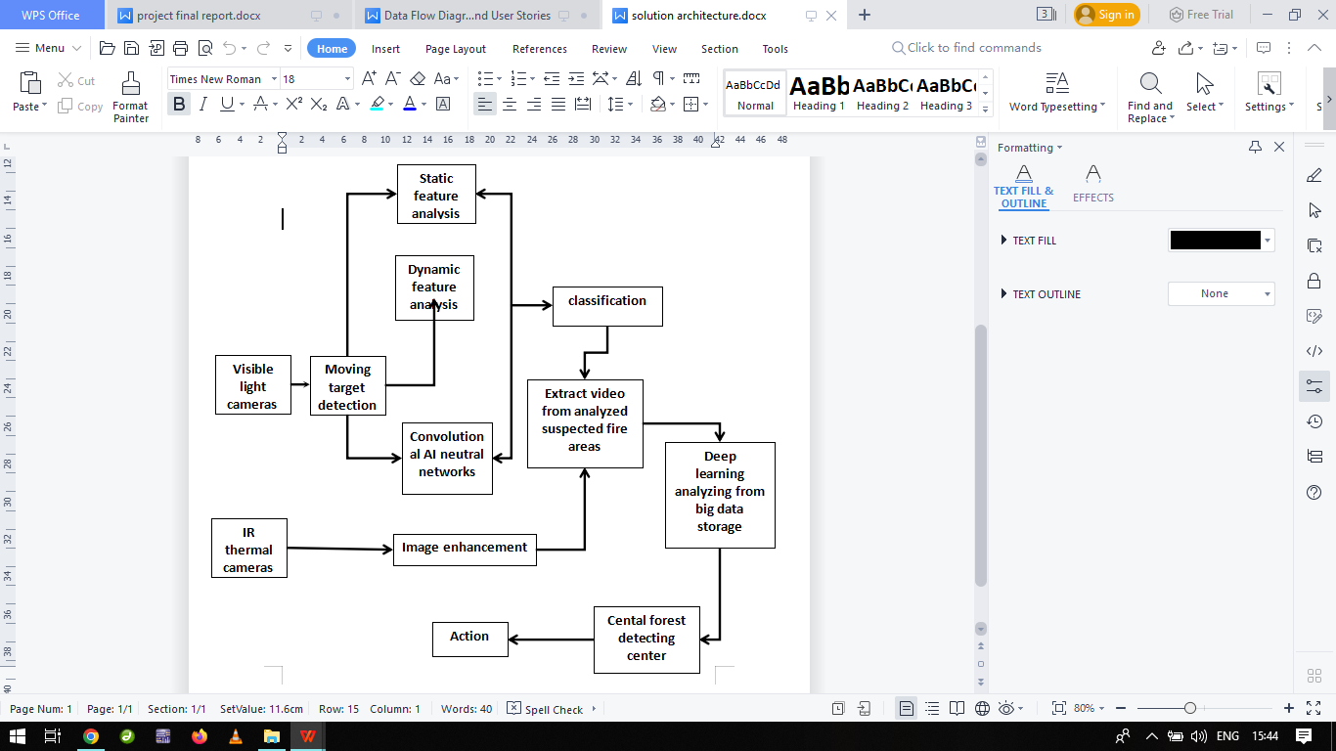

User Stories:
User Type | Functional Requirement (Epic) | User Story Number | User Story / Task | Acceptance criteria | Priority | Release
People who live near forest | Login | USN-1 | As a livelyhood, I want to inform the(forestfire)  Situation to the government. And to protect myself and my family from the forest fire. | I can use my mobile phone and I can inform the situation. | High | Sprint-1
Forest officer | login | USN-2 | As the forest officer, I want to identify the forest fire in early . | I can identify the fire by using cameras. And sensors. | High | Sprint-1
Tourist/ Trecking people | Login | USN-3 | As the humanity based activity, I want to inform and protect myself and the people, aminals and others from forest fire | I can use my mobile phone and I can inform the situation. | High | Sprint-1
Passersby | Login | USN-4 | As the humanity based activity, I want to inform and protect the people, aminals and others from forest fire | I can use my mobile phone and I can inform the situation. | High | Sprint-1

7)PROJECT PLANNING & SCHEDULING
SPRINT PLANNING AND ESTIMATION:
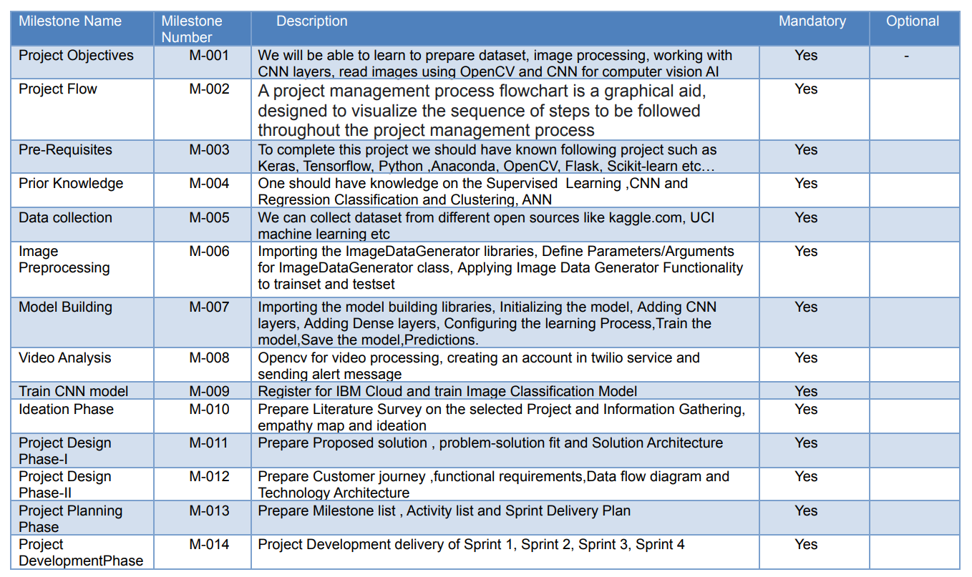
SPRINT DELIVERY SCHEDULING:
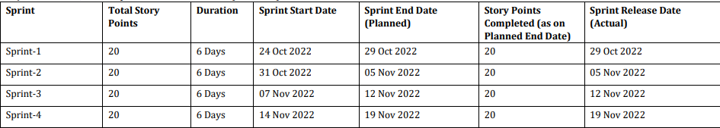

REPORT FROM JIRA:

JIRA has categorized reports in four levels, which are −
Agile
Issue Analysis
Forecast & Management
Others
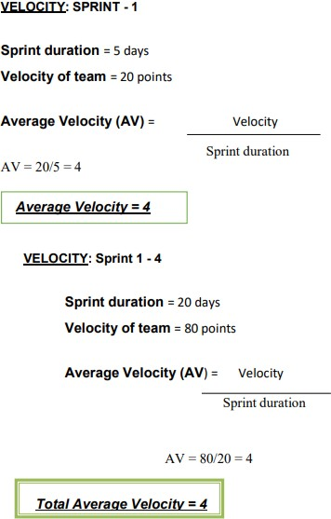

8)CODING & SOLUTIONING (Explain the features added in the project along with code)

FEATURE-1:
!pip install tensorflow
!pip install opencv-python
!pip install opencv-contrib-python
import tensorflow as tf
import numpy as np
from tensorflow import keras
import os
import cv2
from tensorflow.keras.preprocessing.image import ImageDataGenerator
from tensorflow.keras.preprocessing import image
train=ImageDataGenerator(rescale=1./255,
shear_range=0.2,
rotation_range=180,
zoom_range=0.2,
horizontal_flip=True)
train = ImageDataGenerator(rescale=1/255)
test = ImageDataGenerator(rescale=1/255)
train_dataset = train.flow_from_directory("/content/drive/MyDrive/Dataset/train_set",
target_size=(128,128),
batch_size = 32,
class_mode = 'binary' )
test_dataset = test.flow_from_directory("/content/drive/MyDrive/Dataset/test_set",
target_size=(128,128),
batch_size = 32,
class_mode = 'binary' )
test_dataset.class_indices
#to define linear initialisation import sequential
from keras.models import Sequential
#to add layer import Dense
from keras.layers import Dense
#to create convolution kernel import convolution2D
from keras.layers import Convolution2D
#import Maxpooling layer
from keras.layers import MaxPooling2D
#import flatten layer
from keras.layers import Flatten
import warnings
warnings.filterwarnings('ignore')
model =Sequential()
#add convolutional layer
model.add(Convolution2D(32,(3,3),input_shape=(128,128,3),activation='relu'))
#add maxpooling layer
model.add(MaxPooling2D(pool_size=(2,2)))
#add flatten layer
model.add(Flatten())
model.add(Dense(150,activation='relu'))

model.add(Dense(1,activation='sigmoid'))
model.compile(loss = 'binary_crossentropy',
optimizer = "adam",
metrics = ["accuracy"])
model.fit_generator(x_train,steps_per_epoch=14,epochs=5,validation_data=x_test,validation_steps=4)
model.save("/content/drive/MyDrive/archive(1)/forest1.h5")
predictions = model.predict(test_dataset)
predictions = np.round(predictions)
predictions
print(len(predictions))
#import load_model from keras.model
from keras.models import load_model
#import image class from keras
import tensorflow as tf
from tensorflow.keras.preprocessing import image
#import numpy
import numpy as np
#import cv2
import cv2
#load the saved model
model = load_model("/content/drive/MyDrive/archive(1)/forest1.h5")
def predictImage(filename):
img1 = image.load_img(filename,target_size=(128,128))
Y = image.img_to_array(img1)
X = np.expand_dims(Y,axis=0)
val = model.predict(X)
print(val)
if val == 1:
print(" fire")
elif val == 0:
print("no fire")
predictImage("/content/drive/MyDrive/Dataset/test_set/with fire/19464620_401.jpg")
FEATURE-2:
!pip install tensorflow
!pip install opencv-python
!pip install opencv-contrib-python
import tensorflow as tf
import numpy as np
from tensorflow import keras
import os
import cv2
from tensorflow.keras.preprocessing.image import ImageDataGenerator
from tensorflow.keras.preprocessing import image
train=ImageDataGenerator(rescale=1./255,
shear_range=0.2,
rotation_range=180,
zoom_range=0.2,
horizontal_flip=True)
train = ImageDataGenerator(rescale=1/255)
test = ImageDataGenerator(rescale=1/255)
train_dataset = train.flow_from_directory("/content/drive/MyDrive/Dataset/train_set",
target_size=(128,128),
batch_size = 32,
class_mode = 'binary' )
test_dataset = test.flow_from_directory("/content/drive/MyDrive/Dataset/test_set",
target_size=(128,128),
batch_size = 32,
class_mode = 'binary' )
test_dataset.class_indices
#to define linear initialisation import sequential
from keras.models import Sequential
#to add layer import Dense
from keras.layers import Dense
#to create convolution kernel import convolution2D
from keras.layers import Convolution2D
#import Maxpooling layer
from keras.layers import MaxPooling2D
#import flatten layer
from keras.layers import Flatten
import warnings
warnings.filterwarnings('ignore')
model =Sequential()
#add convolutional layer
model.add(Convolution2D(32,(3,3),input_shape=(128,128,3),activation='relu'))
#add maxpooling layer
model.add(MaxPooling2D(pool_size=(2,2)))
#add flatten layer
model.add(Flatten())
model.add(Dense(150,activation='relu'))

model.add(Dense(1,activation='sigmoid'))
model.compile(loss = 'binary_crossentropy',
optimizer = "adam",
metrics = ["accuracy"])
model.fit_generator(x_train,steps_per_epoch=14,epochs=5,validation_data=x_test,validation_steps=4)
model.save("/content/drive/MyDrive/archive(1)/forest1.h5")
predictions = model.predict(test_dataset)
predictions = np.round(predictions)
predictions
print(len(predictions))
#import load_model from keras.model
from keras.models import load_model
#import image class from keras
import tensorflow as tf
from tensorflow.keras.preprocessing import image
#import numpy
import numpy as np
#import cv2
import cv2
#load the saved model
model = load_model("/content/drive/MyDrive/archive(1)/forest1.h5")
def predictImage(filename):
img1 = image.load_img(filename,target_size=(128,128))
Y = image.img_to_array(img1)
X = np.expand_dims(Y,axis=0)
val = model.predict(X)
print(val)
if val == 1:
print(" fire")
elif val == 0:
print("no fire")
predictImage("/content/drive/MyDrive/Dataset/test_set/with fire/19464620_401.jpg")
pip install twilio
pip install playsound
#import opencv librariy
import cv2
#import numpy
import numpy as np
#import image function from keras
from keras.preprocessing import image
#import load_model from keras
from keras.models import load_model
#import client from twilio API
from twilio.rest import Client
#imort playsound package
from playsound import playsound
#load the saved model
model = load_model(r'/content/drive/MyDrive/archive(1)/forest1.h5')
#define video
video = cv2.VideoCapture('/content/Fighting Fire with Fire _ Explained in 30 Seconds.mp4')
#define the features
name = ['forest','with forest']
account_sid='ACfb4e6d0e7b0d25def63044919f1b96e3'
auth_token='f9ae4fc4a617a527da8672e97eefb2d8'
client=Client(account_sid,auth_token)
message=client.messages \
.create(
body='Forest Fire is detected, stay alert',
from_='+1 302 248 4366',
to='+91 99400 12164')
print(message.sid)
pip install pygobject
def message(val):
if val==1:
from twilio.rest import Client
print('Forest fire')
account_sid='ACfb4e6d0e7b0d25def63044919f1b96e3'
auth_token='f9ae4fc4a617a527da8672e97eefb2d8'
client=Client(account_sid,auth_token)
message=client.messages \
.create( body='forest fire is detected, stay alert',
#use twilio free number
from_='+1 302 248 4366',
#to number
to='+91 99400 12164')
print(message.sid)
print("Fire detected")
print("SMS Sent!")
elif val==0:
print('No Fire')
from matplotlib import pyplot as plt
#import load model from keras.model
from keras.models import load_model
#import image from keras
from tensorflow.keras.preprocessing import image
img1 = image.load_img('/content/drive/MyDrive/Dataset/test_set/with fire/Wild_fires.jpg',target_size=(128,128))
Y = image.img_to_array(img1)
x = np.expand_dims(Y,axis=0)
val = model.predict(x)
plt.imshow(img1)
plt.show()
message(val)
img2 = image.load_img('/content/drive/MyDrive/Dataset/test_set/forest/1200px_Mountainarea.jpg',target_size=(128,128))
Y = image.img_to_array(img2)
x = np.expand_dims(Y,axis=0)
val = model.predict(x)
plt.imshow(img2)
plt.show()
message(val)
9)TESTING
TEST CASES:

10)RESULTS
PERFORMANCE MATRICS:
Value obtained from three sensor, if any Infrared ray detected, it gives output as IR detected, Sensor activated! Similarly, if there is any temperature change it will show Abnormal temperature and its intensity. For any smoke detection it output as Smoke detected and sensor value.Above image is result obtained from the trained ML model showing count for damaged and intact homes.
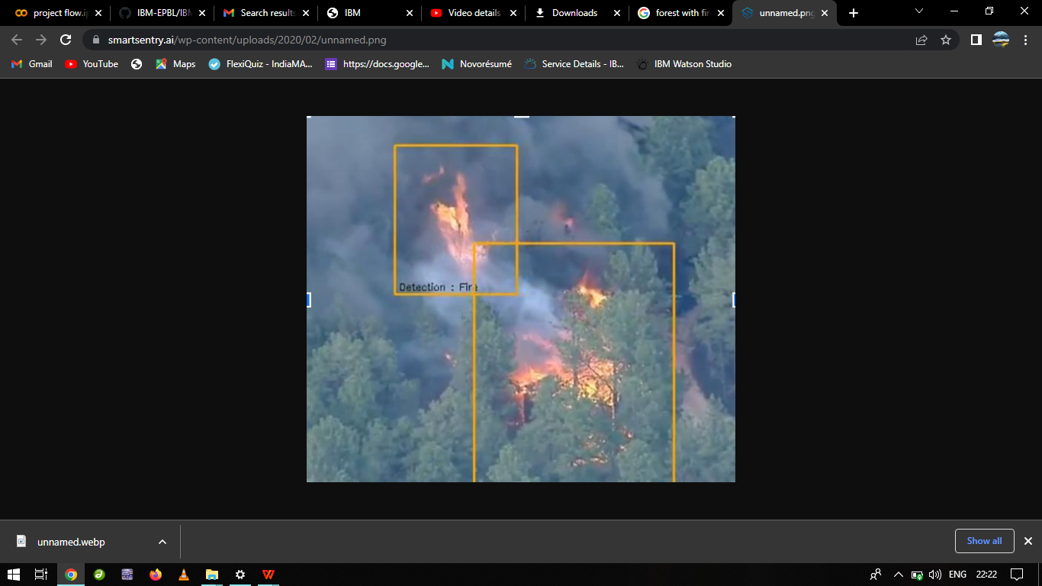

11)ADVANTAGES & DISADVANTAGES
Advantages:
It refreshes the habitat zones: Fire clears out plants and trees to make more natural resources available to the habitat. Fewer trees mean more water becomes available for the remaining plants and animals that call the area their home. New grass and shrubs are food sources for a number of animals as well. A ground cover that comes back after a ﬁre becomes a new micro-habitat. Everything is refreshed with a ﬁre.
Low-intensity ﬁres don’t usually harm trees: The bark of a tree is like an armored shell against ﬁre, pests, and other things that could damage them. Most forest ﬁres burn at low- temperature levels when conditions are optimal and this causes minimal damage to the trees of the forest when it occurs. The end result is a clearing of the ground ﬂoor of the forest while the trees are able to continue standing majestically.
Decreases the Wastes on Forests: Forests have a lot of waste that ends up building up over time and these wastes can help create wildﬁres. If a large wildﬁre breaks out it might take weeks to control it and the damage it can cause is just too extensive to understand for us. Waste such as dead leaves on the ground can be pretty useful for wildﬁres to feed on and small forest ﬁres just deal with these wastes properly without going out of control.

Disadvantages:
A forest ﬁre sets up the potential for soil erosion to occur: Forest ﬁres clear the underbrush away and encourage new growth, but there is a period of time between the ﬁre and the new growth where the forest is vulnerable.
Forest ﬁres always bring death in some form: Maybe it’s just the weak plants of the forest that are killed during a ﬁre, but there is always some sort of death that happens when a ﬁre occurs. Sometimes it is the ﬁreﬁghters who are tasked with stopping the ﬁre. It could be animals or pets.
Uncontrolled ﬁres can cause localized air pollution: Despite the amount of global development that has occurred, there are many forests that are diﬃcult or nearly impossible to reach. Fires in these areas are left to burn in an uncontrolled fashion and this creates air pollution which can affect the local environment and make it diﬃcult to breathe.
12)CONCLUSION
This project will help in early detection of forest ﬁre and the prevention. It also involves the risk factor of analyzing the drone images of affected areas using machine learning algorithm which overcomes the existing project. This system detects the ﬁre conditions in a short time before any ﬁre accidents spreads over the forest area. The scope of using video frames in the detection of ﬁre using machine learning is challenging as well as innovative. If this system with less error rate can be implemented at a large scale like in big factories, houses, forests, it is possible to prevent damage and loss due to random ﬁre accidents by making use of the Surveillance System
13)FUTURE SCOPE
Future Scope In future, we are planning to install smart water tank system in dense forest where reachability of resources and ﬁreﬁghters is diﬃcult. In addition to that we will be updating the system with more features and reliability. We will also include a high pitch sound system that will keep away the animals from the site of ﬁre.The proposed system can be developed to more advanced system by integrating wireless sensors with CCTV for added protection and precision. The algorithm shows great promise in adapting to various environment.

14)APPENDIX

Github: https://github.com/IBM-EPBL/IBM-Project-30216-1660141867

Video demo link: https://youtu.be/zzJNZv824xQ

Thank you

